Quiz over Week 6 and 7

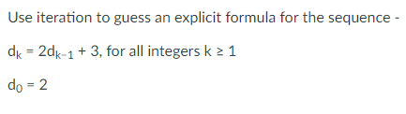

1.) $d_{1}=2\left(2\right)+3=2^{2}+3$ $$d_{2}=2\left(2^{2}+3\right)+3=2^{3}+2⋅3+3 \\ d_{3}=2\left(2^{3}+2⋅3+3\right)+3=2^{4}+2^{2}⋅3+2⋅3+3 \\ d_{4}=2\left(2^{4}+2^{2}⋅3+2⋅3+3\right)+3=2^{5}+2^{3}⋅3+2^{2}⋅3+2⋅3+3$$ Guess: $$d_{n}=2^{n+1}+2^{n-1}⋅3+2^{n-2}⋅3+…+2^{2}⋅3+2⋅2+3 \\ =2^{n+1}+3\sum_{i=0}^{n-1}{2^{i}} \\ =2^{n+1}+3⋅\frac{2^{n}-1}{2-1} \\ =2^{n+1}+3⋅\left(2^{n}-1\right) \\ =2⋅2^{n}+3⋅2^{n}-3 \\ =5⋅2^{n}-3$$

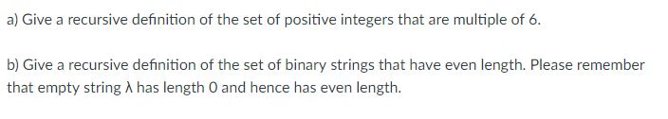

2.a.) Basis step: $6∈S$ Recursive step: $If x∈S, then x+6∈S$

2.b.) Basis step: $λ∈S$ Recursive step: $If w∈S, then 00w∈S, 01w∈S, 10w∈S and 11w∈S$

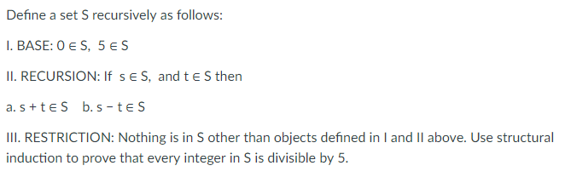

3.) The base objects of $0∈S$ and $5∈S$ are both divisible by 5.  
The recursion for $S$ consists of two rules denoted II(a) and II(b).   
By II(a), $$0+0∈S, 0+5∈S, 5+0∈S, and 5+5∈S$$  
These sums are all divisible by 5. If we were to keep adding up these sums, we would always get a result divisible by 5.  
By II(b), $$0-0∈S, 0-5∈S, 5-0∈S, 5-5∈S$$ 
These differences are all divisible by 5. If we were to keep subtracting these differences, we would always get a result divisible by 5.  
Because no objects other than those obtained through the base and recursion conditions are contained in $S$, it must be the case that every object in $S$ is divisible by 5.

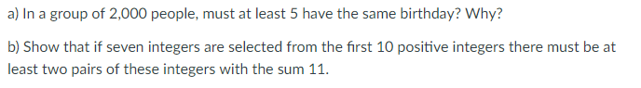

4.a.) 2000/365 = 5.4  
By generalized pigeon hold principle, there are at least 5 people that have the same birthday.

4.b.) We can divide the first ten positive integers into the following subsets: $$\left\{1,10\right\},\left\{2,9\right\},\left\{3,8\right\},\left\{4,7\right\},\{5,6\}$$ 
The sum of each of these subsets is 11.  
Since we choose 7 numbers from 10, 3 numbers are unchosen. That means that there is a maximum of 3 groups chosen. Thus, at least 2 groups are chosen with a sum 11.

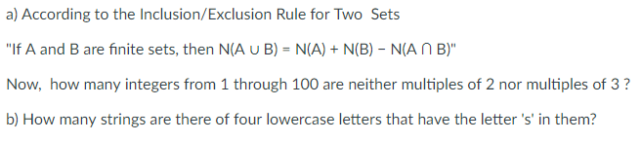

5.a.) Every second integer from 2 to 100 is a multiple of 2, and each can be represented in the form 2j for some integer j from 1 to 50. Thus, there are 50 multiples of 2 in this range.  
Every third integer from 3 to 99 is a multiple of 3, and each can be represented in the form 3k for some integer k from 1 to 33. Thus, there are 33 multiples of 3 in this range.  
However, some integers are both multiples of 2 and 3. In other words, they are divisible by 6. Specifically, every sixth integer from 6 to 96 is a multiple of 6, and each can be represented in the form 6m for some integer m from 1 to 16. Thus, there are 16 multiples of 6 in this range. $$N\left(A∪B\right)=50+33-16=67$$ 
This number represents the numbers from 1 to 100 that are divisible by either 2 or 3. $$100 numbers-67 that are divisible by 2 or 3=33 numbers that are neither multiples of 2 or 3$$

5.b.) There are ${26}^{4}$ strings in all and ${25}^{4}$ that do not have the letter s. Thus, there are ${26}^{4}-{25}^{4}=66,351$  
 that have the letter s.